Directions: The goal of the following problems is to help challenge and deepen your understanding of the current topic. Don’t assume that you will know how to answer every question. You will work with at least two other students in the class to try and find solutions and write arguments for each of the following questions. Be sure that you question your classmates’ reasoning. If you don’t understand how they are getting something, you should ASK THEM TO EXPLAIN! Being able to defend your reasoning is important and so you are actually helping them by asking them to explain.

Challenge Questions

- Consider the region R determined by the curves on the interval .

- Set up, but do not evaluate, an integral which represents the volume of the solid when R is revolved around the line . Include a sketch of your solid and cross sections.

- Set up, but do not evaluate, an integral which represents the volume of the solid when R is revolved around the x-axis. Include a sketch of your solid and cross sections.

- Consider the region R determined by the curves and that lies to the right side of . Set up, but do not evaluate, an integral which represents the volume of the solid when R is revolved around the line . Include a sketch of your solid and cross sections.

- How can you tell whether you will need to use washers or disks to assist in finding the volume of a solid of rotation?

- The region under the graph of , , is rotated about the x and y axes. The graphs below illustrate the solids of revolution which are formed.
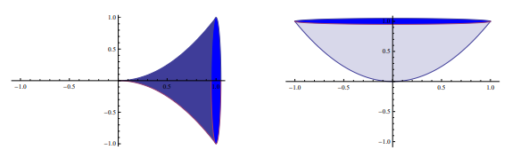

- Set up and evaluate the integral giving the volume of the solid obtained by rotation about the x-axis.

- Without calculating the volume of the other solid determine which solid has a larger volume. (Note that saying “the second figure looks bigger” is not a convincing argument.)

- Consider a solid built onto of the region determined by , , , and .

- Setup, but do not evaluate, an integral which represents the volume of the solid if the cross sections for this solid which are parallel to the y-axis are squares.

- Setup, but do not evaluate, an integral which represents the volume of the solid if the cross sections for this solid which are perpendicular to the x-axis are semi-circles.

- Setup, but do not evaluate, an integral which represents the volume of the solid if the cross sections for this solid which are perpendicular to the y-axis are rectangles which are twice as tall as they are wide.

- Consider a three-dimensional shape standing on the floor with height cm such that the area of a cross section parallel to the floor is for any height cm. What is the volume of the three-dimensional shape?

- Consider the three-dimension object whose base is a semicircle with diameter . If each cross section of the three-dimensional which are perpendicular to are also semicircles, then what is the volume of the resulting object?

- The yellow-colored region in the diagram below is bounded by , where a is a real number such that . What is the value of a that minimizes the volume of the solid obtained by rotating the region around the x-axis?
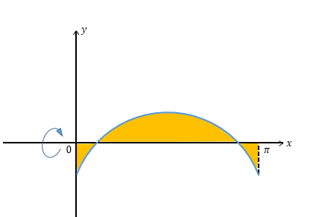

- A vase maker decides to construct a vase whose contour is a cubic polynomial according to the following specifications:
- The vase is 4 feet tall.
- The vase is 4 feet in diameter at its widest (which occurs 1 foot from the base).
- The vase is 2 feet in diameter at its narrowest (which occurs 1 foot from the top).
- The vase has a flat circular bottom.
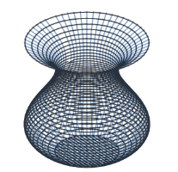
Rounded to 3 decimal places, what is the volume of the vase in cubic feet?

